Adopted June 28, 2004
Amended June 12, 2006
Amended March 8, 2010
Amended April 10, 2023 (Ord.#705)

SOUTHWEST VILLAGE

PUD DEVELOPMENT DESIGN STANDARDS

a. Intent

The purpose of this zone is to create a Mixed Use PUD including a Transit Oriented Development, Neighborhood Commercial and Residential. The use of the PUD zone is to allow for more flexible design standards while creating a higher quality and more sensitive development. Each structure proposed for development shall proceed through site plan review based on the development standards outlined below. The Neighborhood Business District regulations shall apply to Lots 1 and 2, Block 1, except as modified by this ordinance. The R-16 District regulations shall apply to Outlot C, except as modified by this ordinance.

b. Permitted Uses

- The permitted uses in this zone should be limited to appropriate commercial and service uses consistent with meeting the daily needs of the neighborhood and the transit facility users. The uses shall be limited to those as defined herein. If there is a question as to whether or not a use meets the definition, the Community Development Director shall make that interpretation. The type of uses to be provided on these lots shall be low intensity neighborhood oriented retail and service establishments to meet daily needs of residents. Commercial and transit uses shall be limited to the area located north of the access point off of Highway 101. Residential uses shall be located south of the Highway 101 access.
- Coffee shop not to exceed 2,000 square feet with a drive-through is permitted subject to compliance with Section 20-292 of the Chanhassen City Code. A coffee shop is an establishment that primarily serves coffee of various types and may serve cold drinks, such as iced coffee and iced tea, as well as other non-caffeinated beverages.
- Small to medium sized restaurant-not to exceed 8,000 square feet per building (no drive-thru windows)
- Office
- day care
- neighborhood scale commercial up to 12,500 square feet per building footprint
- convenience store without gas pumps
- specialty retail (book store jewelry, Sporting Goods sale/rental, Retail Sales, Retail Shops, Apparel Sales, etc.)
- personal services (an establishment or place of business primarily engaged in providing individual services generally related to personal needs, such as a tailor shop, Shoe Repair, Self-service Laundry, Laundry Pick-up Station, Dry Cleaning, dance studios, etc).
- Park-and-Ride not to exceed 800 spaces.
- Residential High Density (8-16 units per acre).

c. Prohibited Ancillary Uses

- Drive thru Windows
- Outdoor storage and display of merchandise

d. Setbacks

The PUD ordinance requires setbacks from roadways and exterior property lines. The following table displays those setbacks.

Boundary | Building and Parking Setback
Lyman Boulevard | 10 feet
Highway 101 | 20 feet
Highway 212 excluding transit shelters and ramps | 20 feet
Easterly Project Property Line | 100 Feet
Internal Project property lines | 0 Feet
Hard Surface Coverage | 50 %
Commercial and Transit Facility Hard Surface Coverage | 70 %
Maximum Residential Building/Structure Height | 35 feet or 3 stories, whichever is less
Maximum Commercial Building/Structure Height | 1 story
Maximum Park-and-Ride Ramp excluding the elevator shaft and stair well | 35 feet or 3 stories, whichever is less

e. Non Residential Building Materials and Design

1. The PUD requires that the development demonstrate a higher quality of architectural standards and site design. The intent is to create a neighborhood and transit friendly development.

2. All materials shall be of high quality and durable. Major exterior surfaces of all walls shall be face brick, stone, glass, stucco, architecturally treated concrete, cast in place panels, decorative block, or cedar siding. Color shall be introduced through colored block or panels and not painted block or brick. Bright, long, continuous bands are prohibited.

3. Block shall have a weathered face or be polished, fluted, or broken face. Exposed cement (“cinder”) blocks shall be prohibited.

4. Metal siding, gray concrete, curtain walls and similar materials will not be approved except as support material to one of the above materials, or as trim or as HVAC screen, and may not exceed more than 25 percent of a wall area.

5. All accessory structures shall be designed to be compatible with the primary structure.

6. All roof mounted equipment shall be screened by walls of compatible appearing material. Wood screen fences are prohibited. All exterior process machinery, tanks, etc., are to be fully screened by compatible materials. All mechanical equipment shall be screened with material compatible to the building.

7. The buildings shall have varied and interesting detailing. The use of large unadorned, concrete panels and concrete block, or a solid wall unrelieved by architectural detailing, such as change in materials, change in color, fenestrations, or other significant visual relief provided in a manner or at intervals in keeping with the size, mass, and scale of the wall and its views from public ways shall be prohibited. Acceptable materials will incorporate textured surfaces, exposed aggregate and/or other patterning. All walls shall be given added architectural interest through building design or appropriate landscaping.

8. There shall not be underdeveloped backsides of buildings. All elevations shall receive nearly equal treatment and visual qualities.

9. The materials and colors used for each building shall be selected in context with the adjacent building and provide for a harmonious integration with them. Extreme variations between buildings in terms of overall appearance, bulk and height, setbacks and colors shall be prohibited.

f. Residential Standards

1. Building exterior material shall be a combination of fiber-cement siding, vinyl siding, stucco, or brick with support materials such as cedar shakes, brick and stone or approved equivalent materials as determined by the city.

2. Each unit shall utilize accent architectural features such as arched louvers, dormers, etc.

3. All units shall have access onto an interior private street.

4. All mechanical equipment shall be screened with material compatible to the building or landscaping.

5. A design palette shall be approved for the entire project. The palette shall include colors for siding, shakes, shutters, shingles, brick and stone.

6. All foundation walls shall be screened by landscaping or retaining walls.
g. Site Landscaping and Screening

The intent of this section is to improve the appearance of vehicular use areas and property abutting public rights-of-way; to require buffering between different land uses; and to protect, preserve and promote the aesthetic appeal, character and value of the surrounding neighborhoods; to promote public health and safety through the reduction of noise pollution, air pollution, visual pollution and glare.

1. The landscaping standards shall provide for screening for visual impacts associated with a given use, including but not limited to, truck loading areas, trash storage, parking lots, Large unadorned building massing, etc.

2. Each lot for development shall submit a separate landscaping plan as a part of the site plan review process.

3. All open spaces and non-parking lot surfaces, except for plaza areas, shall be landscaped, rockscaped, or covered with plantings and/or lawn material. Tree wells shall be included in pedestrian areas and plazas.

4. Undulating berms, north of Lyman Boulevard and east of Highway 101 shall be sodded or seeded at the conclusion of grading and utility construction. The required buffer landscaping may be installed where it is deemed necessary to screen any proposed development. All required boulevard landscaping shall be sodded.

5. Loading areas shall be screened from public right-of-ways. Wing walls may be required where deemed appropriate.

6. Native species shall be incorporated into site landscaping, whenever possible.

h. Street Furnishings

Benches, kiosks, trash receptacles, planters and other street furnishings should be of design and materials consistent with the character of the area. Wherever possible, street furnishings should be consolidated to avoid visual clutter and facilitate pedestrian movement.

- Signage

The intent of this section is to establish an effective means of communication in the development, maintain and enhance the aesthetic environment and the business’s ability to attract sources of economic development and growth, to improve pedestrian and traffic safety, to minimize the possible adverse effect of signs on nearby public and private property, and to enable the fair and consistent enforcement of these sign regulations. It is the intent of this section, to promote the health, safety, general welfare, aesthetics, and image of the community by regulating signs that are intended to communicate to the public, and to use signs which meet the city's goals:

  - Establish standards which permit businesses a reasonable and equitable opportunity to advertise their name and service;
  - Preserve and promote civic beauty, and prohibit signs which detract from this objective because of size, shape, height, location, condition, cluttering or illumination;
  - Ensure that signs do not create safety hazards;
  - Ensure that signs are designed, constructed, installed and maintained in a manner that does not adversely impact public safety or unduly distract motorists;
  - Preserve and protect property values;
  - Ensure signs that are in proportion to the scale of, and are architecturally compatible with, the principal structures;
  - Limit temporary commercial signs and advertising displays which provide an opportunity for grand opening and occasional sales events while restricting signs which create continuous visual clutter and hazards at public right-of-way intersections.

1. Project Identification Sign:

One project identification and tenant sign shall be permitted for the development at the entrance off of Highway 101. The total area of both Project identification signs shall not exceed 80 square feet in sign display area nor be greater than eight feet in height. The sign shall be setback a minimum of 10 feet from the property line.

2. Monument Sign:

One monument sign shall be permitted at the entrance to the development off of Lyman Boulevard. This sign shall not exceed 24 square feet in sign display area nor be greater than five feet in height. The sign shall be setback a minimum of 10 feet from the property line.

3. Wall Signs:

a. The location of letters and logos shall be restricted to the approved building sign bands, the tops of which shall not extend greater than 20 feet above the ground. The letters and logos shall be restricted to a maximum of 30 inches in height. All individual letters and logos comprising each sign shall be constructed of wood, metal, or translucent facing.

b. Illuminated signs that can be viewed from neighborhoods outside the PUD site are prohibited.

c. Tenant signage shall consist of store identification only. Copy is restricted to the tenant’s proper name and major product or service offered. Corporate logos, emblems and similar identifying devices are permitted provided they are confined within the signage band and do not occupy more than 15% of the sign area unless the logo is the sign.

- Signs along the sides of the retail buildings are permitted.

- Wall-mounted signs along Highway 101 shall be limited to either above the storefront windows when a shared entry configuration exists, and for an unshared configuration, the signage shall be located above the entry or above the tenant’s specific storefront windows, but not both.

- On the east elevation, signage shall be permitted above the storefront only as well as small-scale pedestrian level decorative signage, perpendicular to the wall (projecting signs). The size of the sign shall not exceed 9 square feet.

- A “SW” logo on the elevator shaft of the parking ramp building shall be permitted. The size of the logo shall not exceed a 4 foot diameter along the north elevation. This logo may be back lit.

- A “SouthWest Transit” with a “SW” logo not to exceed a 4-foot diameter along the west elevation shall be permitted. This sign may be back lit.

- A “SouthWest Transit” sign with letters 36 inches high shall be permitted along the south elevation. This sign may not be illuminated.

4. Festive Flags/Banners

a. Flags and banners shall be permitted on approved standards attached to the building facade and on standards attached to pedestrian area lighting.

b. Flags and banners shall be constructed of fabric or vinyl.

c. Banners shall not contain advertising for individual users, businesses, services, or products.

d. Flags and banners shall project from buildings a maximum of two feet.

e. Flags and banners shall have a maximum area of 10 square feet.

f. Flags and banners which are torn or excessively worn shall be removed at the request of the city.

5. Building Directory

a. In multi-tenant buildings, one building directory sign may be permitted. The directory sign shall not exceed eight square feet.

6. Directional Signs

a. On-premises signs shall not be larger than four (4) square feet. The maximum height of the sign shall not exceed five (5) feet from the ground. The placement of directional signs on the property shall be so located such that the sign does not adversely affect adjacent properties (including site lines or confusion of adjoining ingress or egress) or the general appearance of the site from public rights-of-way. No more than four (4) signs shall be allowed per lot. The city council may allow additional signs in situations where access is confusing or traffic safety could be jeopardized.

b. Off-premises signs shall be allowed only in situations where access is confusing and traffic safety could be jeopardized or traffic could be inappropriately routed through residential streets. The size of the sign shall be no larger than what is needed to effectively view the sign from the roadway and shall be approved by the city council.

- Bench signs are prohibited except at transit stops as authorized by the local transit authority.

d. Signs and Graphics. Wherever possible, traffic control, directional and other public signs should be consolidated and grouped with other street fixtures and furnishings to reduce visual clutter and to facilitate vehicular and pedestrian movement. A system of directional signs should also be established to direct traffic within the commercial area and away from residential areas.

7. Prohibited Signs:

- Individual lots are not permitted low profile ground business sign.
- Pylon signs are prohibited.
- Back lit awnings are prohibited.
- Window Signs are prohibited except for company logo/symbol and not the name. Such logo shall not exceed 10% of a window area

8. Sign Design and permit requirements:

a. The sign treatment is an element of the architecture and thus should reflect the quality of the development. The signs should be consistent in color, size, and material and height throughout the development. A common theme will be introduced at the development's entrance monument and will be used throughout.

- All signs require a separate sign permit.

- Wall business signs shall comply with the city’s sign ordinance for the Neighborhood business district for determination of maximum sign area. Wall signs may be permitted on the “street” front and primary parking lot front of each building.
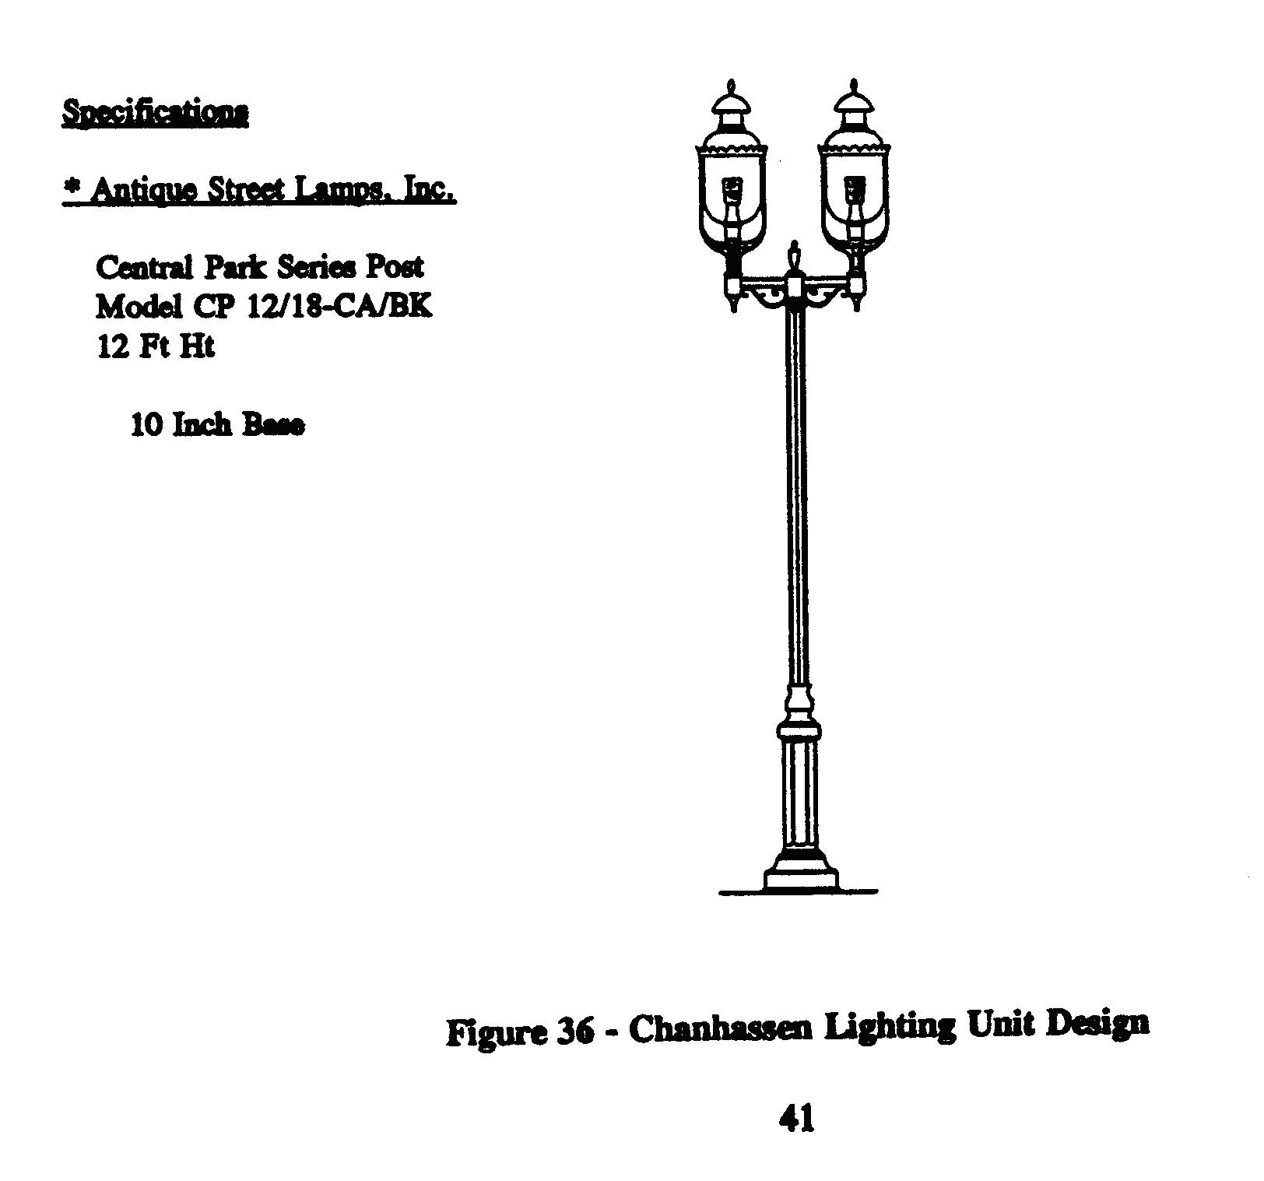
j. Lighting

1. Lighting for the interior of the development shall be consistent throughout the development. High pressure sodium vapor lamps or LED with decorative natural colored pole shall be used throughout the development parking lot area for lighting. Decorative, pedestrian scale lighting shall be used in plaza and sidewalk areas and may be used in parking lot areas.

2. Light fixtures should be kept to a pedestrian scale (12 to 18 feet). Street light fixtures should accommodate vertical banners for use in identifying the commercial area. The fixtures shall conform with (Figure 36 – Chanhassen Lighting Unit Design).

3. All light fixtures shall be shielded. Light level for site lighting shall be no more than 1/2 candle at the project perimeter property line. This does not apply to street lighting.
- Lighting for parking areas shall minimize the use of lights on pole standards in the parking area. Rather, emphasis should be placed on building lights and poles located in close proximity to buildings.

k. Non Residential Parking

1. Parking shall be provided based on the shared use of parking areas whenever possible. Cross access easements and the joint use of parking facilities shall be protected by a recorded instrument acceptable to the city.

- The development shall be treated as an integrated shopping center and provide a minimum of one space per 200 square feet of commercial/retail area. The office/personal service component shall be treated as an integrated office building and provide 4.5 space per 1,000 square feet for the first 49,999 square feet, four per thousand square feet for the second 50,000 square feet, and 3.5 per thousand square feet thereafter.
l. Residential Parking shall comply with city code requirements.”

